Name: Date: ss words

The sound (s) is represented by the letters ss when it comes after a short vowel.

Remember: Say the word aloud, then say each letter aloud as you write it e.g. 'class, c ... l ... a ... s ... s'
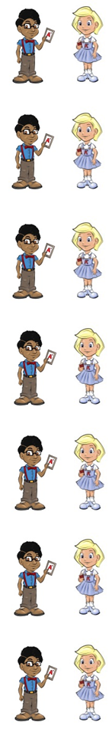
Gail loves to be in class.

Sheep eat grass.

Neil was co close he could not miss.

Do you want more or less?

Nina makes Gail feel stress.

Mum is the boss in our house.

Gail never makes a fuss.

The words gas and bus are naughty red words that belong to Neil and Nina because they have only have one s after a short vowel sound.

Gas can be used to heat a house or to cook with.

A bus can take a lot of people.

Now test yourself without looking at the words and check for yourself if you got them all right. Practice writing any words that you made mistakes on again.

© www.SaveTeachersSundays.com 2013
Name: Date: ss words

The sound (s) is represented by the letters ss when it comes after a short vowel.

Remember: Say the word aloud, then say each letter aloud as you write it e.g. 'class, c ... l ... a ... s ... s'

Try to spell each word without looking at it.

Gail loves to be in .

Sheep eat .

Neil was co close he could not .

Do you want more or ?

Nina makes Gail feel .

Mum is the in our house.

Gail never makes a .

can be used to heat a house or to cook with.

A can take a lot of people.

Now check for yourself if you got them all right. Practice writing any words that you made mistakes on again.

© www.SaveTeachersSundays.com 2013

